**SPRINT-3**

|  |  |
| --- | --- |
| TEAM ID | PNT2022TMID20252 |
| Project Name | IoT Based smart crop Protection system for agriculture |
| Maximum mark | 20 marks |

STEP1: Simulated program to get the random values.

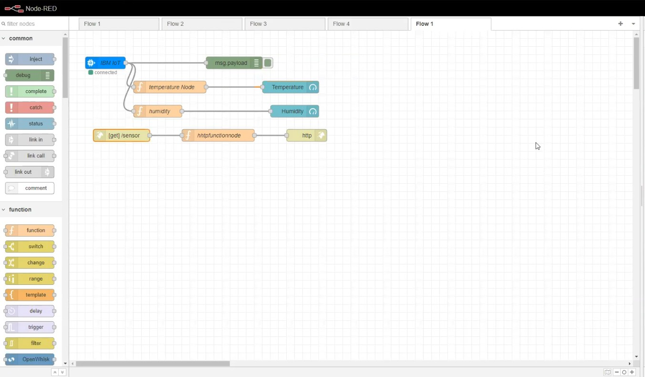

STEP 2: Generate debug message from IBM Watson IoT Platform and connect the nodes.

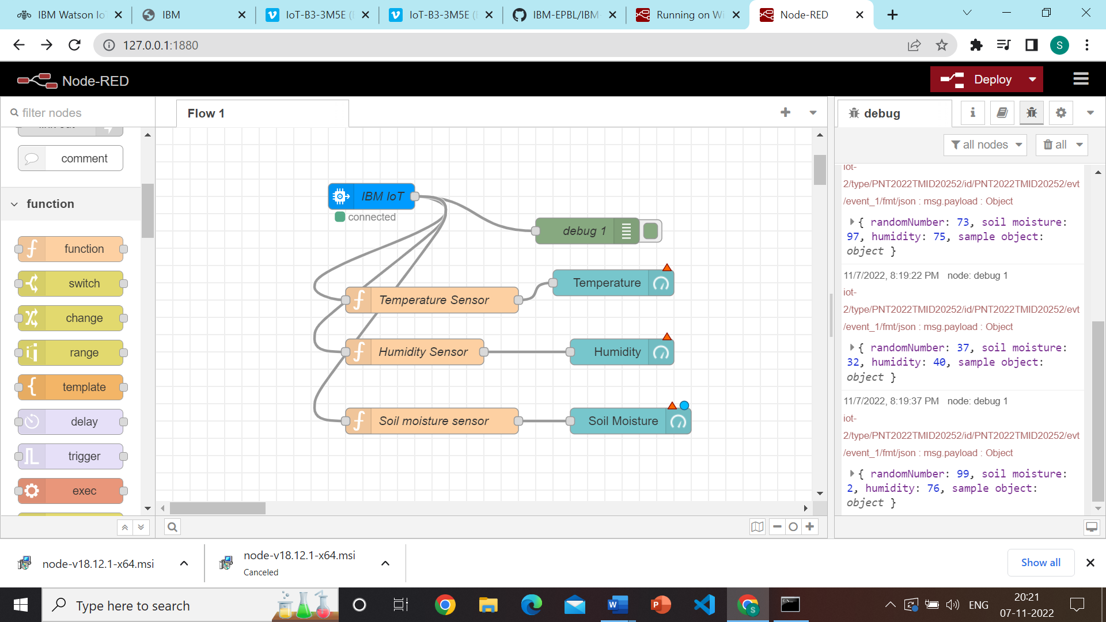

STEP 3: Generate the some output from recent events.

